**Year 10 Physics End of Topic Test**

**Modified**

**Name: \_\_\_\_\_\_\_\_\_\_\_\_\_\_\_\_\_\_\_\_\_\_\_\_\_\_\_ / 27**

**Multiple Choice Answer Sheet – Select ONE answer for each**

[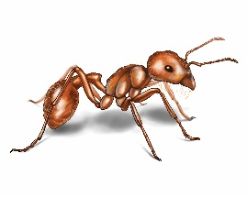](http://www.google.com.au/url?sa=i&rct=j&q=ant&source=images&cd=&cad=rja&docid=xnY1A86yla2paM&tbnid=RzulS6ugMKx4fM:&ved=0CAUQjRw&url=http://www.orkin.com/ants/harvester-ant/&ei=dZs7UrXWFNDDkAWDrIHoDA&psig=AFQjCNH_SG2m2KFbnhWkRaDTwREnye2S-g&ust=1379724529024052)**1** What distance would an ant, crawling at a speed of 2 centimetres per second, cover in an hour? (Distance = Speed x Time)

A 120 cm

B 7200cm

C 1200m

D 7200m

**2** Two forces stretch a cable within a structure. Which of the following best describes the cable?

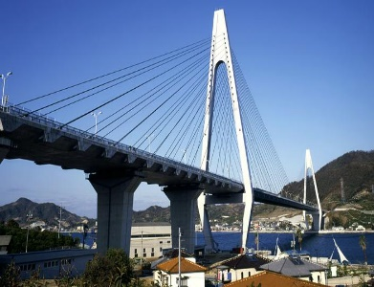

Cables

A The cable is in compression.

B The cable is in tension.

C The cable is being stretched by gravity.

D The cable is unbalanced.

**3** Look at the three pieces of ticker tape below, labelled A, B and C.

[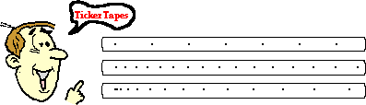](http://www.google.com.au/url?sa=i&rct=j&q=ticker+tape+speed&source=images&cd=&cad=rja&docid=wMhrNsjROP9a0M&tbnid=vzACHjSPZdrteM:&ved=0CAUQjRw&url=http://www.nileswestils.com/ILS/Acceleration.html&ei=-tA7UrGqKIfdkgXOt4HIBA&psig=AFQjCNH19iGDLCD5X9W_FaHQYkKvniD58g&ust=1379738197384806)Choose the answer that explains each piece correctly.

**A**

**B**

|  |  |  |  |
| --- | --- | --- | --- |
| **C** | Piece A | Piece B | Piece C |
| A | Decelerating | Maintaining a constant speed | Accelerating |
| B | Maintaining a constant speed | Accelerating | Decelerating |
| C | Accelerating slowly | Maintaining a constant speed | Decelerating |
| D | Maintaining a constant Speed | Accelerating Slowly | Accelerating faster |

**4** When a door or window sticks it indicates that the structure:

A has partly failed

B has forces acting on it

C has all of its forces balanced

D has no forces acting on it

**5** When standing, your legs are in:

A compression

B tension

C failure

D friction

**6** A cable was placed under tension until just before it broke. Which of the following diagrams best shows the cable just before it broke?

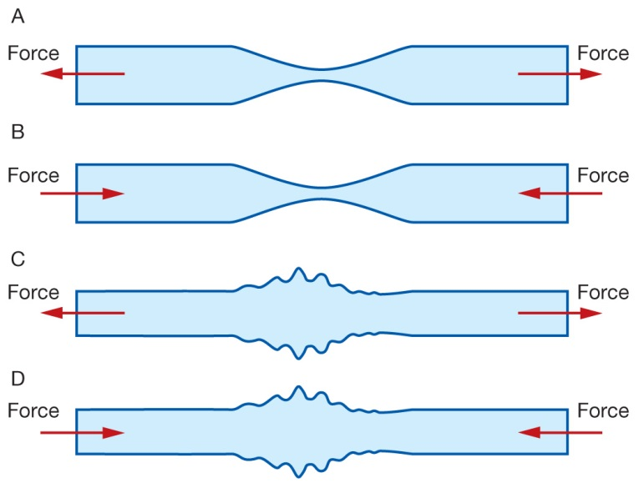

**7** The Bridge (diagram below) is an example of a: [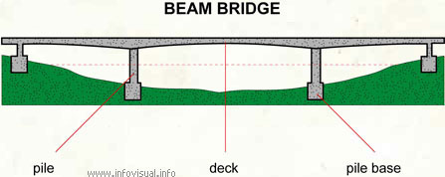](http://www.google.com.au/url?sa=i&rct=j&q=beam%20bridge&source=images&cd=&cad=rja&docid=I-xSqF0PU79-9M&tbnid=9SfHeT76u1K29M:&ved=0CAUQjRw&url=http://www.infovisual.info/05/030_en.html&ei=hhxFUsqbGsOKlQWfnYGQDA&psig=AFQjCNFNUrQOaz3GxlpviXKFtYWnzFtkdw&ust=1380347350129093)

A bowstring arch bridge

B cable-stayed bridge

C suspension bridge

D beam bridge

**8** Which of the following has kinetic energy? (Kinetic is energy of movement)

A A bike parked on a hill.

B A child running.

C A stretched balloon.

D A bumblebee hovering in the same spot.

**9** Which of the following is **not** an example of potential energy? (potential is stored energy)

A A bike parked on a hill.

B A skateboard moving down a hill

C A stretched balloon.

D A ball balanced at the top of a slide

1. **10**  Which of the following stick people would be unstable and most likely to topple over?

|  |  |  |  |
| --- | --- | --- | --- |
| A | PSCI_10PR_9_12Ta | B | PSCI_10PR_9_12Tb |
| C | PSCI_10PR_9_12Tc | D | PSCI_10PR_9_12Td |

**Short Answer**

**1** Are these forces balanced or unbalanced: (6 Marks)

a) A motorbike is accelerating away from traffic lights. \_\_\_\_\_\_\_

b) A car is travelling at 100 km/h straight down a freeway. \_\_\_\_\_\_

c) A surfer falls off their surfboard. \_\_\_\_\_\_

d) A bird flies into a window and bounces off. \_\_\_\_\_\_\_

e) A person standing on one leg \_\_\_\_\_\_\_\_\_\_\_\_\_\_\_\_\_\_\_\_\_\_\_\_\_

f) A building falling over \_\_\_\_\_\_\_\_\_\_\_\_\_\_\_\_\_\_\_\_\_\_\_\_\_

**2.** Mr Lafferty walked around the park as shown in the diagram below.

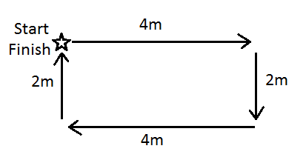

a) Calculate Mr Lafferty’s distance. (1 mark)

\_\_\_\_\_\_\_\_\_\_\_\_\_\_\_\_\_\_\_\_\_\_\_\_\_\_\_\_\_\_\_\_\_\_\_\_\_\_\_\_\_\_\_\_\_\_\_\_\_\_\_\_\_\_\_\_\_\_\_\_\_\_\_\_\_\_\_\_\_\_\_\_\_\_\_\_\_\_\_\_\_

b) Calculate Mr Lafferty’s displacement. (1 mark)

\_\_\_\_\_\_\_\_\_\_\_\_\_\_\_\_\_\_\_\_\_\_\_\_\_\_\_\_\_\_\_\_\_\_\_\_\_\_\_\_\_\_\_\_\_\_\_\_\_\_\_\_\_\_\_\_\_\_\_\_\_\_\_\_\_\_\_\_\_\_\_\_\_\_\_\_\_\_\_\_\_

**3.** Jade rides her bike with a constant speed of 7m/s. It takes 240 seconds to get to school. Calculate how far away school is. (2 marks)

**SHOW ALL OF YOUR WORKING OUT.**

Distance= average speed x time d = v x t

d= v= t=

**4.** This table shows the speed of a man driving a car over time.

|  |  |
| --- | --- |
| **Speed of car (m/s)** | **Time (s)** |
| 5 | 2 |
| 30 | 4 |
| 28 | 6 |
| 10 | 8 |
| 5 | 10 |

Draw a graph using the information from the table above. (5 marks)

REMEMBER all the things that a graph needs!

[](http://www.google.com.au/url?sa=i&rct=j&q=graph+paper&source=images&cd=&cad=rja&uact=8&docid=bnDyK-WDEHhooM&tbnid=OH_xw5ZTcFEuvM:&ved=0CAUQjRw&url=http://virtualmathtutor.blogspot.com/2010/11/how-to-draw-circle-without-compass.html&ei=RKw4U5fxF8fClQWCrIGoCQ&psig=AFQjCNHahbsWAgdANQM5RZCXw4z48cLLBw&ust=1396309252654415)

Describe what happened to the car over time (2 marks)

\_\_\_\_\_\_\_\_\_\_\_\_\_\_\_\_\_\_\_\_\_\_\_\_\_\_\_\_\_\_\_\_\_\_\_\_\_\_\_\_\_\_\_\_\_\_\_\_\_\_\_\_\_\_\_\_\_\_\_\_\_\_\_\_\_\_\_\_\_\_\_\_\_\_\_\_\_\_\_\_\_\_\_\_\_\_\_\_\_\_\_\_\_\_\_\_\_\_\_\_\_\_\_\_\_\_\_\_\_\_\_\_\_\_\_\_\_\_\_\_\_\_\_\_\_\_\_\_\_\_\_\_\_\_\_\_\_\_\_\_\_\_\_\_\_\_\_\_\_\_\_\_\_\_\_\_\_\_\_\_\_\_\_\_\_\_\_\_\_\_\_\_\_\_\_\_\_\_\_\_\_\_\_\_\_\_\_\_\_\_\_\_\_\_\_\_\_\_\_\_\_\_\_\_\_\_\_\_\_\_\_\_\_\_\_\_\_\_\_\_\_\_\_\_\_\_\_\_\_\_\_\_\_\_\_\_\_\_\_\_\_\_\_\_\_\_\_\_\_\_\_\_\_\_\_\_\_\_\_\_\_\_\_\_\_\_\_\_\_\_\_\_\_\_\_\_\_\_\_\_\_\_\_\_\_\_\_\_\_\_\_\_\_\_\_\_\_\_\_\_\_\_\_\_\_\_\_\_\_\_\_\_\_\_\_\_\_\_\_\_\_\_\_\_